A Murder Mystery in Minnesota

World Bible

High Concept

On January 20th, 2004, the population of Cosmos, Minnesota was 544. On January 21st, it was 543. As Jimmy Oden, a police officer for the Metro, you’ve been called upon for this murder. The reason why is that he knew the man who was murdered - he grew up with him. Coming back, something isn’t quite right. It feels like nothing has changed...like time has frozen. People keep speaking of your friend as if he was still alive when he is most assuredly dead. In fact, nothing has seemed changed since you’ve left over a decade ago...

Story

In “A Murder Mystery in Minnesota”, time has frozen for the small town of Cosmos, MN. When a friend of Jimmy’s, Gerald Loughlin, turns up dead, the entire town doesn’t react to his death, not even his own family. However, Jimmy’s presence starts to disrupt this time stop, almost as if modernity ruins older towns...

Without getting too pretentious, that is the main point of the game. The major theme is the idea that these older rural towns are slowly losing their culture and history as newer and newer things come into the 21st century. As such, the best way I thought to examine this concept is to use a real world town, my hometown, and have it be frozen in time.

The key reason for this? A casual loop in time where Gerald tried to stop an intruder from breaking into his house back in 1994, only for the intruder to be himself from 2004. Through time shenanigans, the victim is never properly identified and this could have repeated countless, countless times. Only on this loop, Gerald ends being identified as the victim.

Time Travel Explained

Time travel is a wonky concept in fiction, no matter how anyone goes about it. It gets even more wonky considering that this story is not meant to be a time travel story, merely using it as a setup. Regardless, the explanation for how our time travel works is going to be as such.

Like all scientists, he had a thirst for knowledge. In particular, he wanted to give back to his hometown community by experimenting on possible methods for farmers to continue supporting their families through the winter. One such experiment involved a homemade attempt at a particle accelerator, slamming plant DNA and animal DNA together in order to fuse them. However, since it wasn’t the sturdiest creation, it started to break down during its inaugural run. As it’s melting down, a loose bolt comes loose and propels itself through Gerald’s head, killing him.

The particle accelerator melts down, but rather than blow up, it sends out a massive sine-type wave of temporal energy, causing the home to stay untouched, but being strong enough to affect organic and inorganic material in Cosmos, causing it to revert back to the state it was prior every 24 hours, effectively creating a time loop. What this means is that Gerald’s home and Jimmy’s home (located nearby) are not affected by the loop, but the town and all of its residents are. This time loop will continue to exist until enough outside interference causes it to disperse, i.e., Jimmy becoming involved in the lives of the residents of Cosmos, MN.

Geography/Look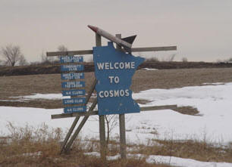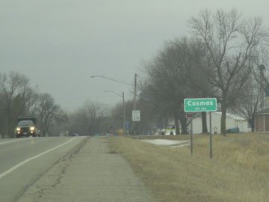

These two images are what I want the basis for the general look of the game. Very bleak, muted colors abound. Since the game takes place in winter, there would be blotchy spots of snow throughout the town. Almost always cloudy overhead, the colors and usage thereof should help illustrate the idea of a town frozen in time, both literally and figuratively. Muted greens, grays, and blues would be the primary palate.

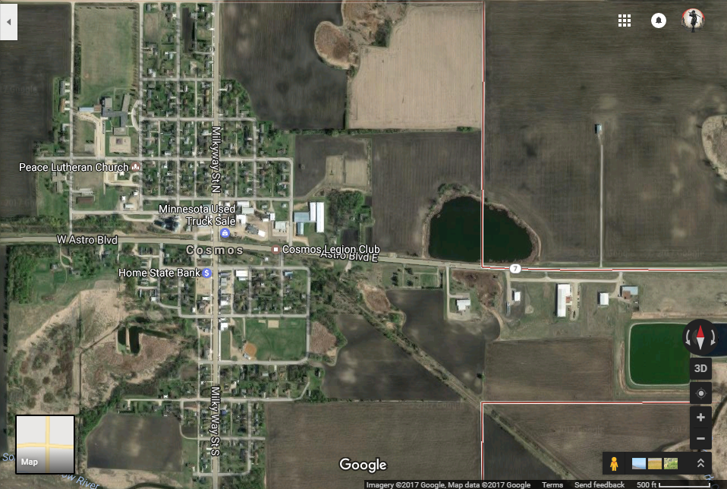

The entirety of Cosmos is our playground, but there would be key locations for our investigation and these would act as zones of play.

* Cosmos Legion Club - Restaurant and Bar, frequent location of gathering.
* Paula’s Place - another bar. Growing up, I would think of this bar as the “bar for drunkards”.
* Peace Lutheran Church - Churches are a staple gathering place in small communities like this.
* ACGC South Elementary - the elementary school.
* Orion Ave - Houses here for suspects
* South Central Grain & Energy - Red herrings through suspicious workers.
* 393 Milky Way Ave - Growing up, this house had always intrigued me. There’s a mystery to it that I had and I want this house to deliver the same amount of mystery.

Families

There are several families that the player should interact with, and all of them should act upbeat, happy, and like nothing has gone wrong in their worlds. Crippling debt? It’s fine. Child’s depressed? We’re good. Gas leak in the house? Must be the turkey in the oven.

* The Petersons - Family of five, related to the Petersens
  + Michael - stay at home
  + Michelle - Works at South Central Grain & Energy
  + Mikhail (pronounced Michael)- 5th grade at the Elementary
  + Michéal - 4th grade at the Elementary
  + Michel - 3rd grade at the Elementary
* The Petersans - Family of three, related to the Petersons
  + Richard - Father, Works out of town
  + Danielle - Mother, Works at the convenience store part-time
  + Danny - Daughter, out of town for college.
* The Petersens - Family of six, related to the Petersans.
  + Peter - Father, works at South Central
  + Patricia - Stay at home
  + Peter #1-4 - Identical quadruplets - all in 4th grade.
* The Nelsons - Family of two, related to the Louglins
  + Mary - Single mother
  + Able - troublemaker in 8th grade.
* The Nelsens - Family of four, related to the Nelsons
* The McCoughlins - Family of two, related to Nelsens
  + Mr. and Mrs. McCoughlin - Secluded couple on the south side of town.
* The Loughlins - No family, now deceased.
* The McLoughlins - Family of one, related to The Nielsens (who do not live in Cosmos, but the remaining area, red herring)
  + Pastor McLoughlin - leader of the Peace Lutheran Church. Lives alone.

Confusing, ain’t it? That’s the point. It should be a challenge to keep all the names straight, because growing up, there actually were two different Peterson families and two different Nelson families. This should serve the writers to be as obtuse as possible in creating.

This makes the inclusion of a journal the player can write in to help them keep things straight and to beckon back to older adventure games.

Technology

* Period correct minus the time travel. The RAZR V3 is the must-have phone, the 2004 Chevy Grand Prix is cool, and the library is the common place to go access the internet.
* Time travel is explained very minimally. The less we explain, the better. All we know is that Gerald somehow got himself into a time loop of killing himself every ten years, and that it finally stopped, closing the loop.
* The murder weapon should be a hunting rifle of some sort, since hunting is popular in this area.
* Audio should match up with this, along with modeling art assets. Be as true to the period as we can.

Religion

* Lutheran Christianity is the dominant religion. Do research on the tenets and beliefs of this branch of christianity.
* We are still in reality, so there might be followers of Catholicism or Judaism.

Politics

* The story should be taking place during some form of campaigning for the leader of the Legion Club. Use this as a red herring through and through, this has nothing to do with the murder. Make it look like it though.

Ending

Through your investigation, you are slowly undoing this time bubble, but this opens up the people of Cosmos to the reality of their situation. Things grow dimmer for them, and by the end of it all, and as you leave, the town should be as it looks - a sad, depressing state of affairs as people wake up from their sleepy town fantasy.